IFT 166 Introduction to Internet Networking
Lab 5
The “Switch”

After you complete each step, put a ‘√’ or ‘x’ in the completed box
Following on from Lab 5 where we used the hub as the network device, we will now use a switch in the center as opposed to a hub.
- Create the following topology in Packet Tracer

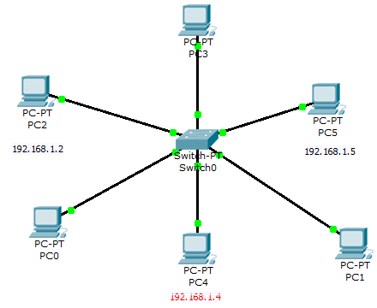

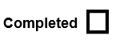

- The first thing we will do is show the MAC address on the switch. As you would expect the MAC address table should be empty as no traffic has gone through it. Click on the switch, go to the CLI tab (hit return, maybe more than once) and they on the command ‘show mac address-table
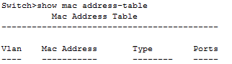


- Go into simulation mode and make sure that APR and ICMP are the only protocols enabled. We will now a packet from PC2 to PC5. As we did in lab 5, hit the capture button and see the packet travel. The switch will do a broadcast that requested by the ARP. PC5 will accept it.
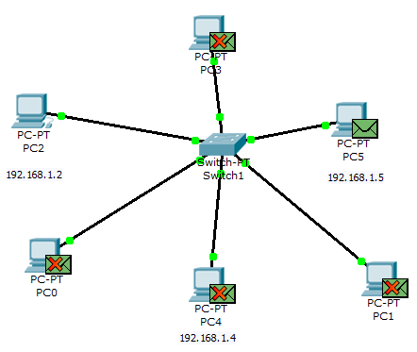



- Hit capture forward and this time PC5 will send back a reply. Notice that the reply only goes put one port from the switch and PC2 accepts the packet.
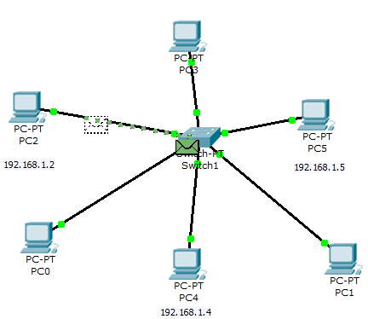



- Now check the MAC address table on the switch and the ARP table on PC2

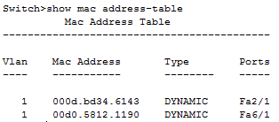
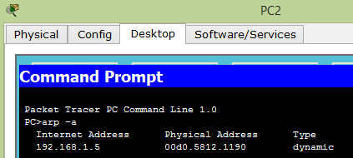



- Now ping PC5 again from PC2 and see how the switch handles the ping. The switch delivers the packet direct to the PC and no broadcast is required.

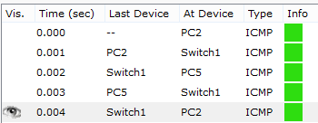



- As a final step, clear the ARP cache (table) on PC2 and then once again ping PC5 from PC2 and see what happens……
